Fecha del documento: 26/04/22

**Alcance del proyecto**

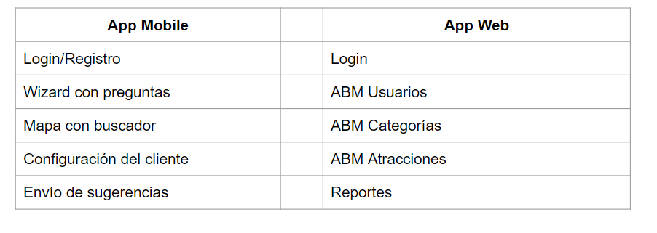

[*https://docs.google.com/document/d/1nv4acW-7nnw6c-30_vNgoq2u2RKgmuWImDfFUrzlu9M/edit?usp=sharing*](https://docs.google.com/document/d/1nv4acW-7nnw6c-30_vNgoq2u2RKgmuWImDfFUrzlu9M/edit?usp=sharing)

